Web Basics - JavaScript Lab Book

## Create prob2.html to display Formatted Hello World by using JavaScript by embedding Hello World in <H1> tag.

**Solution:**

**Step 1:** Create **prob2.html** page to complete the following code and save in lab1 directory.

<html>

<head>

<title>Displaying Formatted Text using JavaScript</title>

</head>

<body>

<script>

//TODO: Display hello world embedded in h1 tag with align attribute value right

</script>

</body>

</html>

## Example 2: Lab 1: Prob2.html

**Step 2:** Open **prob2.html** page in the browser, and verify that you get the same output as required.



## Figure 2: Formatting Text in JavaScript

* 1. **: Create page to show use of external JavaScript Solution:**

**Step 1:** Create **Prob3.html** to complete the following code and save it in lab1 directory.

<html>

<head><title>Using External Script file in HTML Document</title>

<script src="HelloWorld.js">

</script>

</head>

<body>

<hr>

<p>The actual script is in external script file called "HelloWorld.js"</p>

<script>

//TODO: Insert the code here to invoke the function sayHello() in the file HelloWorld.js

</script>

<hr>

</body>

</html>

## Example 3: Lab 1: Prob3.html

**Step 2:** Create a file **HelloWorld.js** which should have a function **sayHello()** that returns a string “Hello World”.

function sayHello()

{

//TODO:return the string “Hello World“

}

## Example 4: Lab 1: HelloWorld.js

**Step 3:** Open **prob3.html** page in the browser, and verify that you get the same output as required.

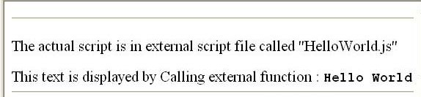

## Figure 3: Using external JavaScript File

**Step 4:** Create **Prob4.html** page and complete the following code and save it in lab1 directory.

<html>

<head><title>Embedding Script tag in HTML Document</title>

<script>

//TODO:use write method in document object to display the desired output

</script>

<hr>

<script src="Hello.js">

</script>

</head>

<body>

<script>

//TODO: use write method in document object to display desired the output

</script>

<hr>

<p><code>The actual script is in external script file called "Hello.js"</code></p>

<script>

//TODO: Insert your code here to call the function dispHello() from the Hello.js file

</script>

<hr>

</body>

</html>

## Figure 4: Lab 1: Prob4.html

**Step 5:** Create a file **Hello.js** which should have a function **dispHello()** that returns a string “Hello World”.

function dispHello()

{

//TODO:return the string “Hello World“

}

## Example 5: Lab 1: Hello.js

**Step 6:** Open **prob4.html** page in the browser, and verify that you get the same output as required.

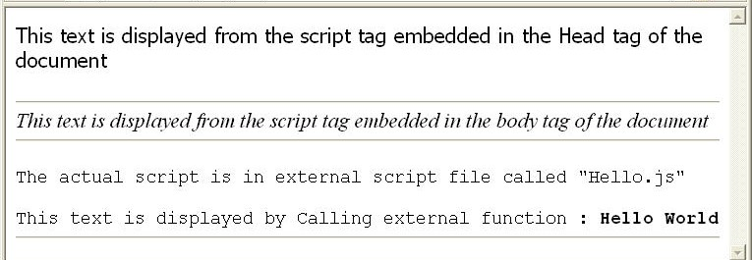

## Figure 5: Embedding Script tags in HTML document

* 1. **: Using Variable in many Script tags Solution:**

**Step 1:** Create **Prob5.html** page, and complete the following code and save it in lab1 directory.

<html>

<head><title>Embedding Script tag in HTML Document</title>

<script>

/*

TODO:define variable headVar and initialize it to some integer value and display the value as shown in the Fig 6

*/

</script>

<hr>

</head>

<body>

<script>

/*

TODO:define variable bodyVar and initialize it to some integer value and display the value as shown in the Fig 6

*/

</script>

<hr>

<script src="common.js">

</script>

<script>

/*

TODO: Invoke the method addNos(headVar,bodyVar) defined in common.js file and pass the two variables headVar and bodyVar defined in the head and the body script tag and display the added result as shown in the Fig 6

*/

</script>

<hr>

</body>

</html>

## Example 6: Lab 1: Prob5.html

**Step 2:** Create a file **common.js** which has a function **addNos()** that adds two numbers and returns the addition of two numbers.

var msg;

msg="<p><code>The actual script is in external script file called common.js</code></p>";

function addNos(headVar,bodyVar)

{

//TODO: display the contents of the variable "msg"

//TODO: display the addition of two numbers

}

## Example 7: Lab 1: common.js

**Step 3:** Open prob5.html page in the browser, and verify that you get the same output as required.

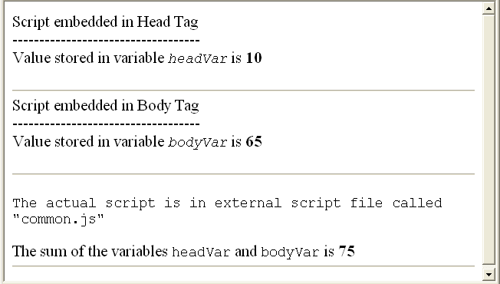

## Figure 6: Using Variable in many Script tags

# Lab 2:The JavaScript Language

|  |  |
| --- | --- |
| **Goals** | * Learn to use looping structures and operators in JavaScript. |
| **Time** | 20 minutes |

## : For loop in JavaScript

Create a web page containing a heading “Layout is here” followed by a horizontal rule and a table with a single row as shown in the figure given below.

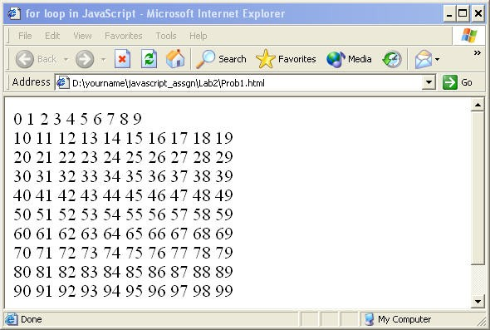

## Figure 7: For loop in JavaScript

After completing the loop, the variable used, that is **“I”**, should be equal to **100**. **Solution:**

**Step 1:** Write the code and save it as **Prob1.html** in lab2 directory.

**Step 2:** Open **prob1.html** page in the browser, and verify that you get the same output as required.

**Step 3:** Create **prob1_dowhile.html** and **prob1_whiledo.html** page using **do…while** and **while…do** control statements respectively to display similar output as shown in the figure given above.

## : Create a web page to calculate the Compound Interest using the formula given below:



**Compund Interest**

**Where:**

**p = Principal,**

**r = Rate of Interest, n = period in years**

**The values used in the example in the following figure are as follows: P = 1000, n = 1, r = 10**

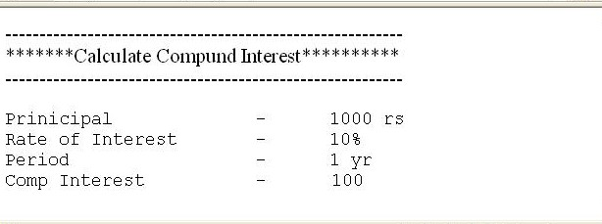

**Figure 8: Operators and Arithmetic Expression**

**Solution:**

**Step 1:** Write the code, and save it in lab2 directory.

**Step 2:** Open page in the browser, and verify that you get the same output as required.

# Lab 3:Working with Predefined core objects

|  |  |
| --- | --- |
| **Goals** | Understand Date, String Object  Learn to use Date and String objects in HTML pages |
| **Time** | 45 minutes |

## : Displaying Date using Date Object

Create a web page **Prob1.html**. In this web page, create a **date** object and use the **getXXXX** functions of the date object to display today’s date in the format as shown below in the figure and also greet the user depending on the time the user visits the page. The message to be displayed is given in the following table. The time column shows the current date hour value.

|  |  |
| --- | --- |
| **Time** | **Msg to be displayed** |
| < 12 | Good Morning |
| >= 12 and <= 17 | Good Afternoon |
| > 17 | Good Evening |

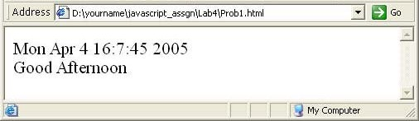

## Figure 9: Displaying Date using Date Object

**Solution:**

**Step 1:** Write the Code, and save it as Prob1.html in lab4 directory.

**Step 2:** Open prob1.html page in the browser, and verify that you get the same output as required.

## : Using indexOf function of String object

Create a web page **prob2.html**, which uses the **indexOf** method of string object and displays the index number of the substring searched for within the string.

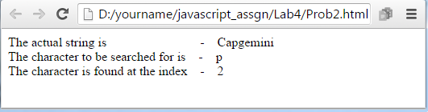

## Figure 10: Using indexOf method of String object

**Solution:**

**Step 1:** Write the Code and save it as **Prob2.html**.

**Step 2:** Open **prob2.html** page in the browser, and verify that you get the same output as required.

## : Using various String methods

Write **prob3.html** page by completing the following code that demonstrates some of the methods of the String objects like match, **substr**, **lowerCase**, and **upperCase** to produce the output as shown in the figure given below:

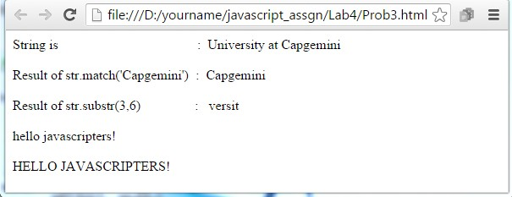

## Figure 11: Using various String methods

**Solution:**

**Step 1:** Write the Code and save it as **Prob3.html**.

**Step 2:** Open **prob3.html** page in the browser, and verify that you get the same output as required.

# Lab 4:Working with Arrays

|  |  |
| --- | --- |
| **Goals** | Work with Array Object |
| **Time** | 10 minutes |

## .1: Using Array to display values

Create a **prob1.html** web page containing script. In this script, declare an array of 6 employee names and display it in the browser as shown below:

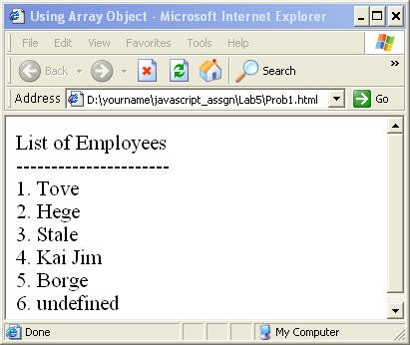

## Figure 12: Using Array to display values

**Solution:**

**Step 1:** Write the Code, and save it as **Prob1.html**.

**Step 2:** Open **prob1.html** page in the browser, and verify that you get the same output as required.

# Lab 5:Working with Document Object Model(DOM)

|  |  |
| --- | --- |
| **Goals** | Understand Window Object  Dynamically create windows Handle window events |
| **Time** | 90 minutes |

## .1: Window object

Create a **prob1.html** web page which has the following items as shown in the figure given below:

* + a form that accepts window parameters width, height, title, left and top parameters from text field, and
  + two buttons with the labels **New Window** and **Reset** to the web page

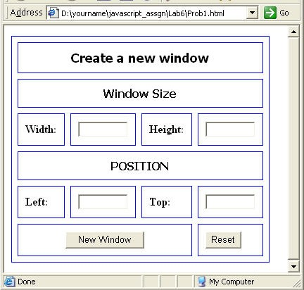

## Figure 13: Interface to accept window coordinates

If **Reset** button is clicked, then clear all text fields. If **New Window** button is clicked, then open a new window with specifications entered in the text fields as shown in the figure given below.

**Note:** By default, the new window opens at the top left corner of the screen.

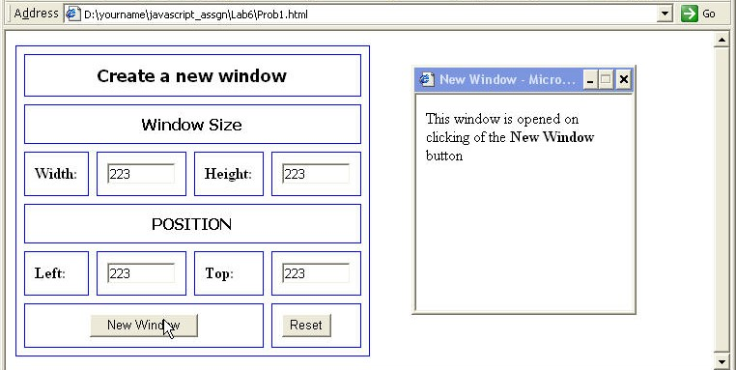

## Figure 14: Opening a window

**Solution:**

**Step 1:** Complete the following Code and save it as **Prob1.html.**

<html>

<head>

<title> window example </title>

</head>

<script>

function nwindow()

{

/*TODO: get the height, width, left and top from the form object and pass the values to open method of window along with the name of the html file to be opened in the new window.*/

}

</script>

<body >

<form id="frmlab">

<table border="1" cellspacing="8" cellpadding="10" bordercolor="blue">

// Create Table as shown in fig 6.2

</table>

</form>

</body>

</html>

## Example 8: Lab 5: Prob1.html

**Step 2:** Open **prob1.html** page in the browser, and verify that you get the same output as required.

**Step 3:** Open **prob2.html** page in the browser, and verify that you get the same output as required.

# Lab 6:Working with Location Object

|  |  |
| --- | --- |
| **Goals** | Understand and use Location Object. |
| **Time** | 20 minutes |

## 6.1: Location Object

Create a web page which will display the properties **href**, **protocol**, and the **pathname** of the location object of your current file.

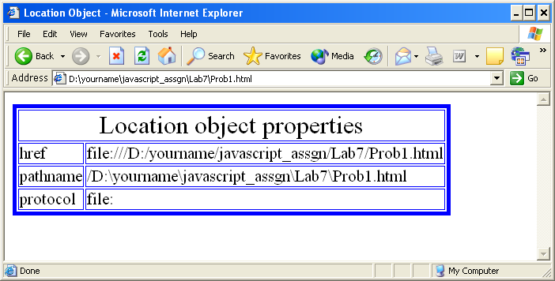

## Figure 15: Location Object Properties

**Solution:**

**Step 1:** Write the code and save it as **Prob1.html**.

**Step 2:** Open **prob1.html** page in the browser, and verify that you get the same output as required.

# Lab 7:Working with Document Object

|  |  |
| --- | --- |
| **Goals** | Understand Document Object |
| **Time** | 120 minutes |

## 7.1: Working with Documents

Create a **prob1.html** web page which displays products available as shown in the following figure. The product details comprise Product Name, Product description, and its price.

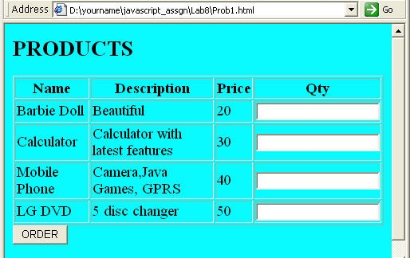

## Figure 16: Displaying Products

Users can place orders specifying the quantity of each product. If the user does not enter quantity in any of the text fields, then an error message should be displayed as shown in the figure given below:

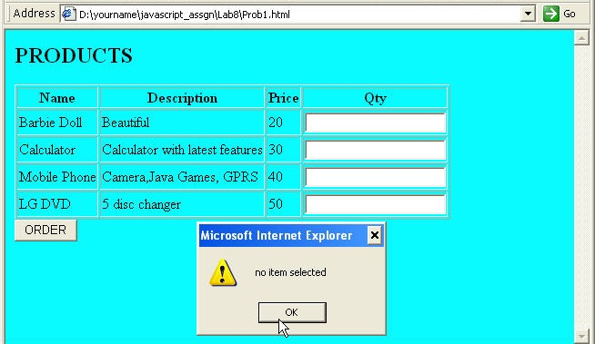

## Figure 17: Validating Products

When the user clicks the **Order** button, the invoice for the current products transaction showing the product name, quantity ordered, price and total amount is displayed in a new window as shown in the figure given below:

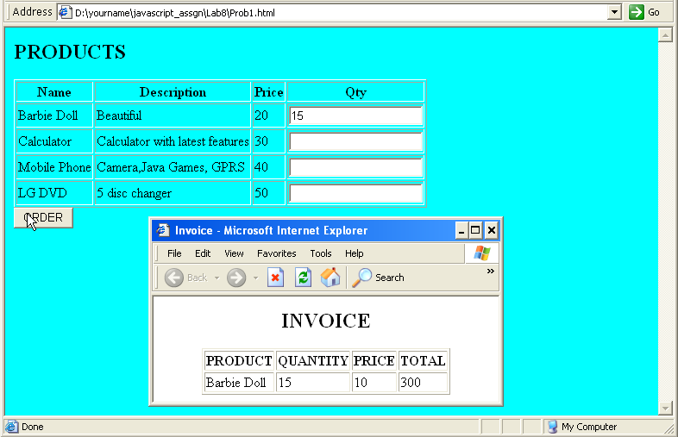

## Figure 18: Displaying Invoice details in a new window

**Solution:**

**Step 1:** Write the code and save it as **Prob1.html**.

**Step 2:** Open **prob1.html** page in the browser, and verify that you get the same output as required.

# Lab 8:Working with Form Object

|  |  |
| --- | --- |
| **Goals** | * Understand and use Form Object. |
| **Time** | 90 minutes |

## : Form Validation

Create a **prob1.html** web page, as shown below, and calculate **Payment Information** based on **Loan Information**. Validate **Loan information** textfields for numbers. The **Payment Information** textfields should be uneditable. The other constraints are as follows:

* + - Amount of Loan should not be more than 15 lakhs.
    - Repayment period should be between 7 yrs to 15 yrs.

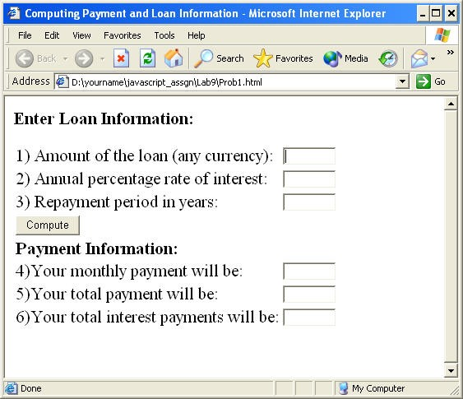

## Figure 19: Validating Form elements

If the repayment period is not between 7 and 15, then an error message should be displayed next to this control.

Similar kind of error message should be displayed if the amount of loan exceeds 15 lakh.

In the function calculatePayment()

/* TODO:

calculate the monthly payment, total payment, total interest payment on click of the button with label "compute"

*/

## Example 9: Lab 8: Prob1.html

Open **prob1.html** page in the browser, and verify that you get the same output as required.

## Validate Field

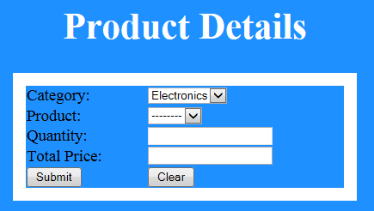Create a **prob2.html** page as shown in the below figure.

## Figure 20: Lab 8.2 Product Details

Data should be prepopulated in category list box (Electronics, Grocery). Based on selection of category, product list need to be populated automatically with values as given in the below table. Also Total price need to be calculated for the entered quantity as per the data in the below table. Total price field should be non-editable field.

|  |  |  |
| --- | --- | --- |
| **Category** | **Product** | **Price per quantity in**  **Rupees** |
| Electronics | Television | 20000 |
| Laptop | 30000 |
| Phone | 10000 |
| Grocery | Soap | 40 |
| Powder | 90 |

While clicking on submit button, if all the text fields contains valid values then display the filled details in a popup window.